Assignment

Authors

Ahmed Shehata 1991-03-21

Alexandria

Egypt

2020-06-20

Table of Contents

1 Task 1 3

1.1 Problem statement 3

1.2 Solution 3

2 Task 2 4

2.1 Problem statement 4

2.2 Results FEM model 4

2.3 Results FEM commercial Abaqus shell element 6

3 References 7

Appendix 1 8

Appendix 2 10

# Task 1

## Problem statement

In this task it required to plot the deformed shape of the mast due to the static load of 20 KN.

## Solution

The mast can be considered as a cantilever beam due to it is totally fixed from one end and free from the other end (the one in which the horizontal axis wind turbine is installed).

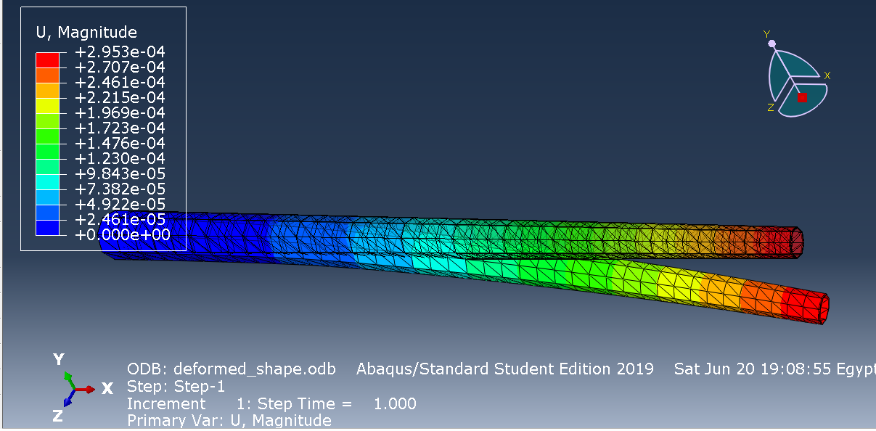

Figure 1the deformed shape of the steel mast due to a load of 20 KN

# Task 2

## Problem statement

* 1. Calculate the fundamental natural frequency of the mast by two different models:
  2. a. A Finite Element code on MATLAB (or equivalent) using beam elements.
  3. b. A Finite Element model on any software package using shell elements.

## Results FEM model

To find the fundamental natural frequency we need to solve the equation of motion for free vibration for the undamped system in the form

$$\left[K\right]\left\{x^{oo}\right\}+\left[M\right]\left\{x\right\}=0$$

Where [K] is known as a stiffness matrix and [M] is known as the mass matrix.

This two matrices can be obtained from discretize the whole beam into small elements .each one has its own mass and stiffness and according to [1] the overall mass and the stiffness matrices can be obtained from assembling this small elements into the overall mass and and stiffness matrices .

This elements for beams can be obtained using Euler Bernoulli beam theory. Due to this type of beams has 4 degree of freedom two rotation and two translation a cubic shape function needs to be used.

And according to the same reference[1] every element mass and stiffness matrices can be obtained from the relation

$${[K]}_{i}=\int{{[b]}^{T}[D]}\left[b\right]l_{i}dξ=\frac{E_{i}I_{i}}{l_{i}^{3}}\int{{[a^{''}(ξ)]}^{T}[a^{''}(ξ)]}dξ$$

$${[M]}_{i}=\int{ρ_{i}{[a]}^{T}[a]}A_{i}l_{i}dξ$$

Where we have [a] is the cubic shape function matrix and [D]is the elasticity matrix which can be expressed in the form $E_{I}I_{i}$ where E is the young module and I is the second moment of inertia.

In this problem and for the sake of simplicity and because we have a very long mast and the variation in the diameter can be considered very small. Furthermore, due to the very small thickness of the mast we will treat the hollow truncated cone as a Hollow cylinder.

This will lead as to find the stiffness and mass matrices for every element

$${[k]}_{i}=\frac{2E_{i}I_{i}}{l_{i}^{3}}\left[\begin{matrix}6 & 3l_{i} & -6 & 3l_{i} \\ 3l_{i} & {{2l}_{i}}^{2} & -3l_{i} & {l_{i}}^{2} \\ -6 & -3l_{i} & 6 & -3l_{i} \\ 3l_{i} & {l_{i}}^{2} & -3l_{i} & 2{l_{i}}^{2}\end{matrix}\right]={\left[\begin{matrix}k_{11} & k_{12} & k_{13} & k_{14} \\ k_{21} & k_{22} & k_{23} & k_{24} \\ k_{31} & k_{32} & k_{33} & k_{34} \\ k_{41} & k_{42} & k_{43} & k_{44}\end{matrix}\right]}^{i}$$

$${[m]}_{i}=\frac{ρ_{i}A_{i}l_{i}}{420}\left[\begin{matrix}156 & 22l_{i} & 54 & -13l_{i} \\ 22l_{i} & {{4l}_{i}}^{2} & 13l_{i} & -3{l_{i}}^{2} \\ 54 & 13l_{i} & 156 & -22l_{i} \\ -13l_{i} & {{-3l}_{i}}^{2} & -22l_{i} & 14{l_{i}}^{2}\end{matrix}\right]=\left[\begin{matrix}m_{11} & m_{12} & m_{13} & m_{14} \\ m_{21} & m_{22} & m_{23} & m_{24} \\ m_{31} & m_{32} & m_{33} & m_{34} \\ m_{41} & m_{42} & m_{43} & m_{44}\end{matrix}\right]$$

This type of beam as we mentioned before has 4 degree of freedom a translation and a rotation for every node of the two-node element.

As we can see every two elements is sharing in a node and that lead to formulate this node from two different elements.

For example, node 2 is described by $u_{3}and u_{4}$ when it comes to formulate $u_{3}and u_{4}$ in the global matrix it will be as following:

$\{\begin{matrix}u_{3} \\ u_{4}\end{matrix}\}={\left[\begin{matrix}k_{11} & k_{12} \\ k_{21} & k_{22}\end{matrix}\right]}^{2}+{\left[\begin{matrix}k_{33} & k_{34} \\ k_{43} & k_{44}\end{matrix}\right]}^{1}$

After creating the mass and the stiffness matrices then we can find the eigen values and vectors. That can be obtained by so many different ways but in this project, the MATLAB eig (K, M) was used for more details check appendix 1.

Then the fundamental natural frequency obtained and compared to the analytical solution

$$f_{FEM}=1.08190$$

$$f_{analytical}=1.081891$$

## Results FEM commercial Abaqus shell element

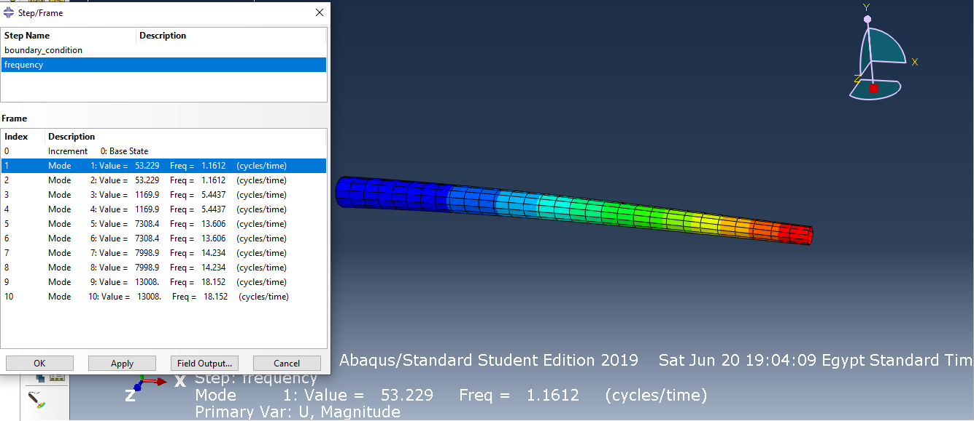

Figure 2 the fundamental natural frequency of the mast using shell element in Abaqus

The major difference when it comes to create this model is the use of the shell element S4 type.

In such a model the shell element is accurate enough due to the ratio

$$\frac{thickness}{height}$$

is very small.

See appendix 2 for the INP file

# References

[1] J.-S. Wu, *Analytical and Numerical Methods for Vibration Analyses*. New York, SINGAPORE: John Wiley & Sons, Incorporated, 2014.

Appendix 1

%%% the MATLAB file is in the attachment

clear all

close all

clc

%%%% this code is to find the fundamentale natural frequency for a mast

%%%% carrying a horizontal axis wind turbine

%%%the 1 st section is to calculate the area and define the cantiliver beam

%%%

rho=8050; %the mass denisty of the mast

L=60; % the Height of the mast

D_og=4; r_og=D_og/2; %the outer diameter of the lower part of the mast

D_ou=2; r_ou=D_ou/2; %the outer diameter of the lower part of the mast

t=.0508; % the thickness of the mast

e=10; % number of elements in the global system

n1=(2*e)+2; % the number of nodes in the global system

NI=e+1;

Lx=linspace(0,L,NI);

Li=Lx(2)-Lx(1); %the element lengtth

ri=r_og-t;

A=pi*(r_og.^2-ri.^2); % the area of the cylinder

I=((pi/4)*(r_og.^4-ri.^4)); % the second moment of inertia

E=2*10^11; %young module

%% formulation for the local K matrix then insert it in the global Matrix

kii=zeros(n1,n1);

K=zeros(n1,n1);

ki=(2*E*I/Li.^3)*[6 (3*Li) -6 (3*Li);(3*Li) (2*Li^2) (-3*Li) (Li.^2);-6 (-3*Li) 6 (-3*Li);(3*Li) (Li^2) (-3*Li) (2*Li.^2)];

%%

for i=1:e

% creating the local matrix for each element

kii((2*i)-1:(2*i)+2,(2*i)-1:(2*i)+2)=ki;

% adding the element into the global matrix

K=K+kii;

kii=zeros(n1,n1);

end

%% formulation for the local M matrix then insert it in the global Matrix

mii=zeros(n1,n1);

M=zeros(n1,n1);

mi=(rho*Li*A/420)*[156 (22*Li) 54 (-13*Li);(22*Li) (4*Li^2) (13*Li) (-3*Li.^2);54 (13*Li) 156 (-22*Li);(-13*Li) (-3*Li^2) (-22*Li) (4*Li.^2)];

for i=1:e

mii((2*i)-1:(2*i)+2,(2*i)-1:(2*i)+2)=mi;

%%%% adding the local mass element into the global matrix

M=M+mii;

mii=zeros(n1,n1);

end

%%

% Boundary conditions (cantilever beam) fixed at one end

% the 1 st two node describing the movement of the lower end of the mast

% (translation and rotation ).

K(1:2,:)=[];

K(:,1:2)=[];

M(1:2,:)=[];

M(:,1:2)=[];

%% find the eigen value and the natural frequency for the cantilever beam

D=eig(K,M);

omega=sqrt(D);

f=omega/(2*pi);

f_fund_num=f(1)

%%

% the analytical solution

f_fund_anly=((1.8751^2)/(2*pi*L^2))*sqrt((E*I)/(rho*A))

Appendix 2

The INP file is in the attachment